**FEE TRANSMITTAL FORM**

**Based on USPTO Form PTO/SB/17**

**Docket No. RUTHERFORD-015-PROV**



**FEE TRANSMITTAL FOR PROVISIONAL PATENT APPLICATION**



**APPLICANT INFORMATION**

**Applicant/Inventor:** Brian James Rutherford

**Application Number:** To Be Assigned

**Filing Date:** _________________

**Docket Number:** RUTHERFORD-015-PROV

**Title of Invention:**

Ultra-Low Latency Quantum-Inspired Decision Engine with Deliberate Accuracy Optimization for Real-Time Cybersecurity Defense



**METHOD OF PAYMENT (check one)**

* **Credit Card** - Credit Card Payment Form (PTO-2038) is attached ☐ Check or Money Order enclosed

☐ The Director is authorized to charge fees to Deposit Account No. _______

☐ Electronic Payment via EFS-Web

☐ Electronic Payment via Patent Center



**FEE CALCULATION**

**BASIC FILING FEES - PROVISIONAL APPLICATION**

|  |  |  |  |  |  |  |  |  |  |  |
| --- | --- | --- | --- | --- | --- | --- | --- | --- | --- | --- |
|  | **Fee** | **Description** | **Standard** | **Small Entity** | **Micro Entity (75%** | **Quantity** | **Total** | | |  |
|  | **Code** | **Fee** | **(50%)** | **off)** |  |
|  |  |  |  |  |  |  |
| 1023 | | Provisional Application | $300 | $150 | **$75** | 1 | **$75** |  |  |  |
| Filing Fee |  |  |  |
|  |  |  |  |  |  |  |  |  |  |
|  |  |  |  |  |  |  |  |  |  |  |
|  |  |  |  |  |  |  |  |  |  |  |
|  |  |  |  |  |  |  |  |  |  |  |

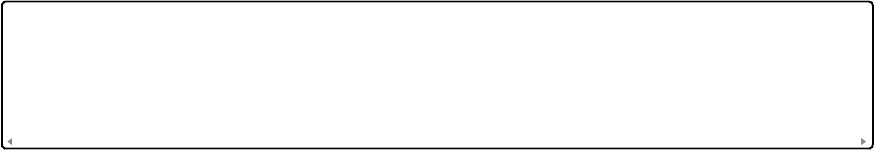

**ADDITIONAL FEES (if applicable)**



|  |  |  |  |  |  |  |
| --- | --- | --- | --- | --- | --- | --- |
|  | **Fee Code** | **Description** | **Micro Entity Fee** | **Quantity** | **Total** | |
|  | N/A | No additional fees for provisional | $0 | 0 | $0 |  |
|  |  |  |  |  |  |  |
|  |  |  |  |  |  |  |
|  |  |  |  |  |  |  |



**TOTAL FEES DUE**



|  |  |
| --- | --- |
| **Entity Status** | **Amount** |
|  |  |
| Standard Entity | $300 |
|  |  |
| Small Entity | $150 |
|  |  |
| **MICRO ENTITY (SELECTED)** | **$75** |
|  |  |

**TOTAL AMOUNT DUE: $75.00**



**ENTITY STATUS**

* Large Entity
* Small Entity
* **MICRO ENTITY** - Certification of Micro Entity Status is attached (Form SB/15A)

**Note:** False claims of micro entity status are subject to penalties under 37 CFR 1.29(i)



**PROVISIONAL APPLICATION CONTENTS**

The following documents are submitted with this provisional application:

* Specification (85 pages)
* Drawings (15 sheets)
* Application Data Sheet (ADS)
* Micro Entity Certification
* Cover Sheet
* Fee Transmittal (this form)
* Credit Card Payment Form
* Information Disclosure Statement (optional)



**CREDIT CARD INFORMATION SUMMARY**

**Payment Method:** Credit Card

**Amount to Charge:** $75.00

**See attached Form PTO-2038 for complete credit card details**



**CORRESPONDENCE ADDRESS**

Please send all correspondence regarding this application to:

Brian James Rutherford

6 Country Place Drive

Wimberley, TX 78676-3114

United States

Telephone: (512) 648-0219

Email: [Actual@ScrappinR.com](mailto:Actual@ScrappinR.com)



**AUTHORIZATION AND SIGNATURE**

The undersigned hereby authorizes the USPTO to charge the indicated fees and any additional fees required or credit any overpayment to the credit card identified in the attached PTO-2038.

I certify that I am: ☑ The inventor/applicant

* An attorney or agent registered to practice before the USPTO
* A person authorized to act on behalf of the applicant

**Name:** Brian James Rutherford

**Signature:** /Brian James Rutherford/

**Date:** _________________

**Telephone:** (512) 648-0219

**Registration Number:** N/A (Pro Se Inventor)



**WARNING**

Knowingly making any false statement in this fee transmittal may subject the applicant to criminal penalties under 18 U.S.C. 1001. Additionally, claiming false entity status may subject the applicant to penalties under 37 CFR 1.29(i).



**FOR USPTO USE ONLY**

Receipt Date: _________________

Amount Received: $_________________

Payment Method: _________________

Deposit Account: _________________



**Form PTO/SB/17 (Modified for RUTHERFORD-015-PROV)**

**Page 1 of 1**